Set up the Environment Variables

Once the installation is done, you need to set up the Java path in your system.

Step 1: Go to your PC setting and click on Advanced system settings from the system dialog window.

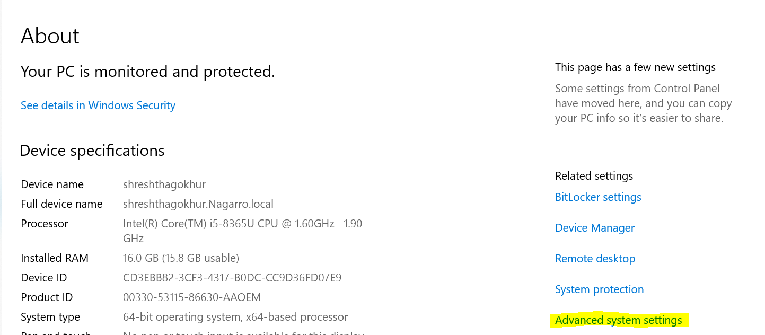

Step 2: Click on Environment variable button.

Step 3: Under System variable, select path and click on Edit button. Now, set the complete Java path and click on save.

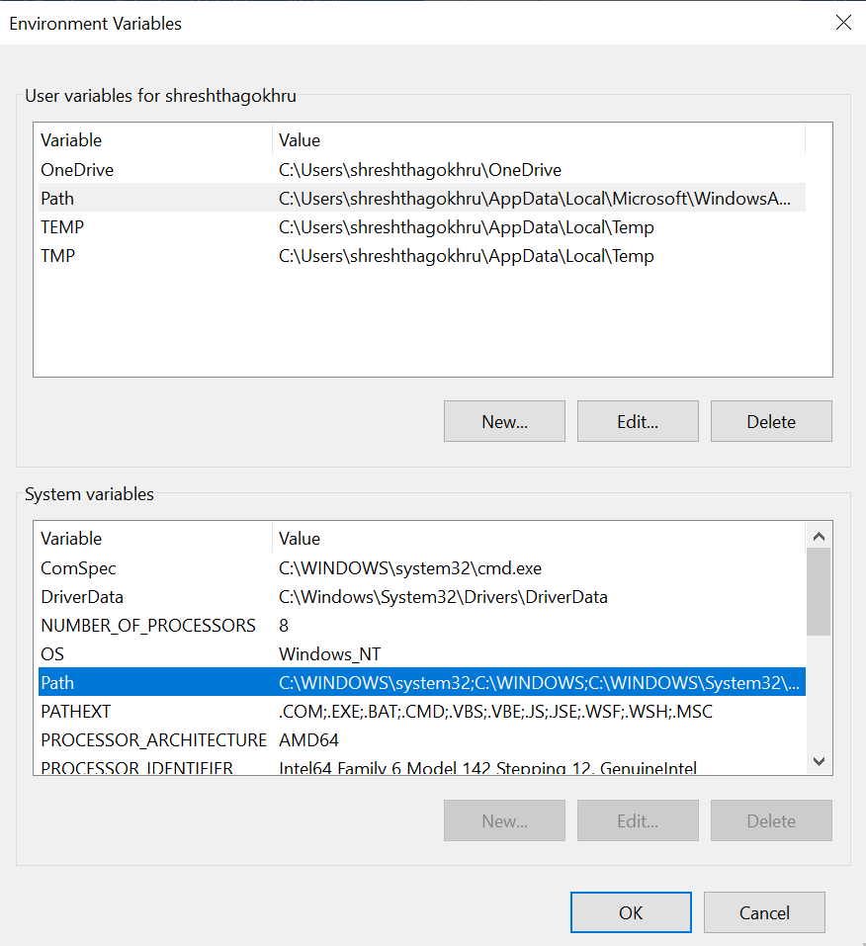

Step 4: To verify whether Java is installed in your system or not, you can open a Command prompt and run the below command:

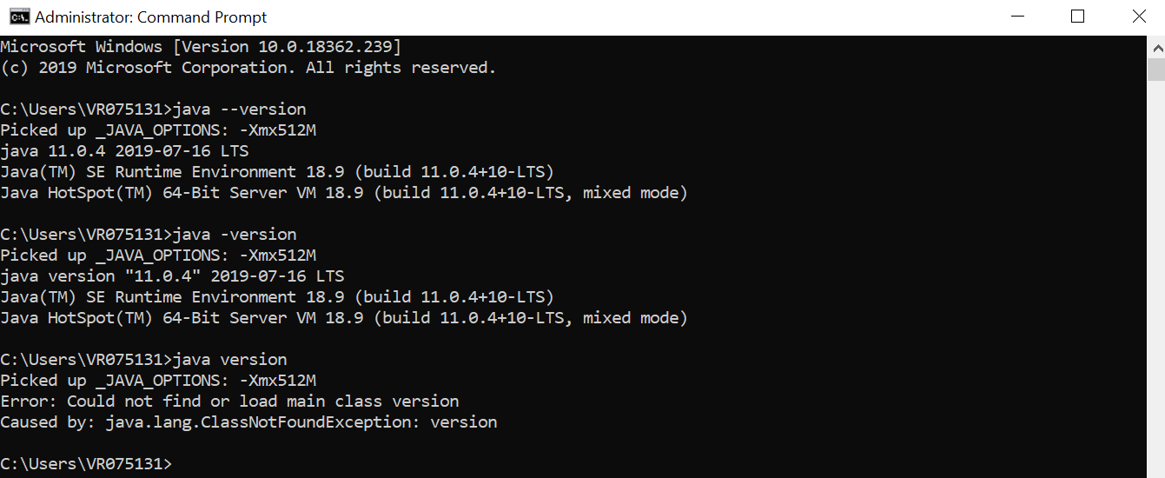

Step 5: Download and install Selenium Client and WebDriver languages Bindings from the Selenium Website.

Selenium standalone server 4Change Log Extract the downloaded folder of your choice from where you can use it later.

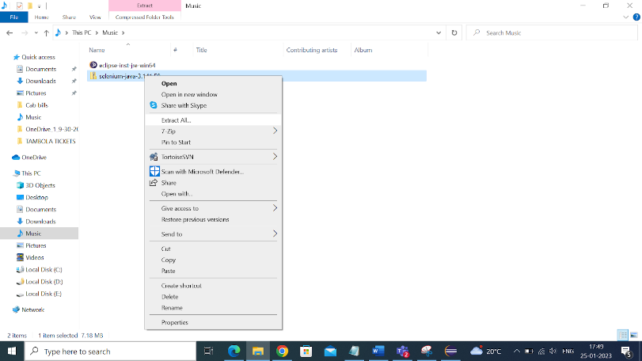

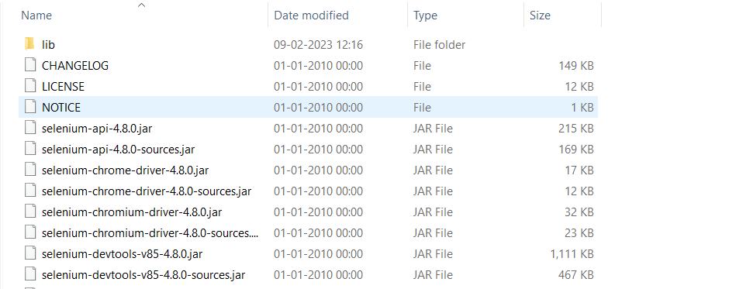

Download and Install Eclipse for Selenium WebDriver

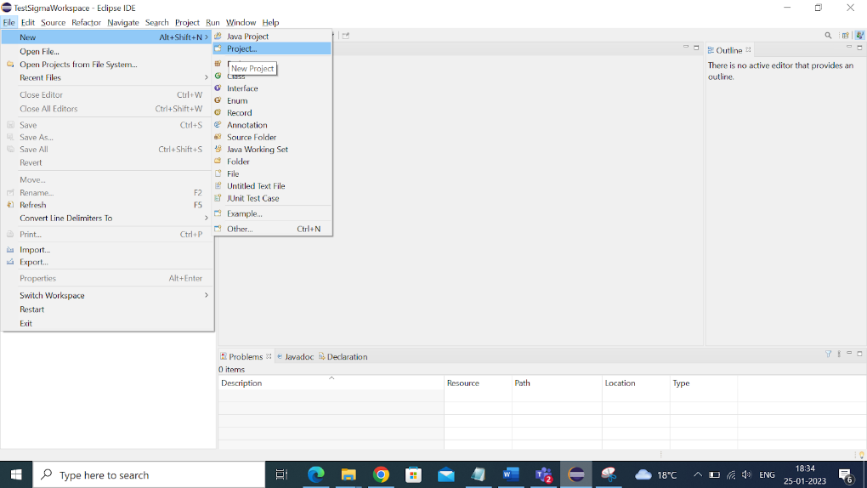

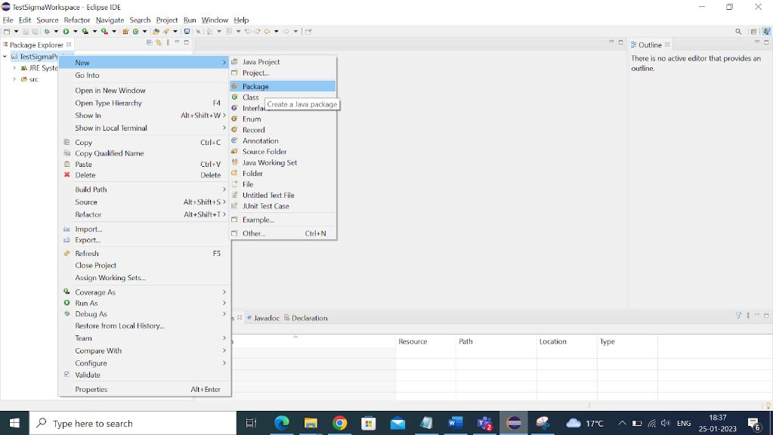

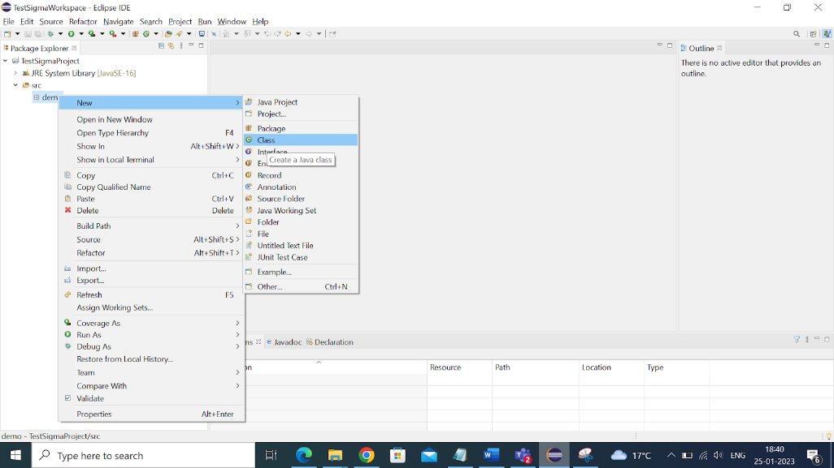

Project > Properties > Java Build Path > Add External JARs

